BUS 1000 Career Success Skills Credit-By-Examination (CBE)

Thank you for your interest in Ranken Technical College's BUS 1000 Career Success Skills CBE. The fee to take this CBE is $90 payable to Ranken Technical College. This fee, which must be paid before you schedule the exam, is non-refundable regardless of your final score. Before you pay your fee, please read the following information and completely review this study guide.

To get started:
- Review the following information and ensure you are comfortable with the details.
- Prepare your business documents, which must be submitted when you schedule your appointment (review the rubrics at the end of this packet to ensure that you are meeting the standards expected of this Credit-By-Examination):
  - Current job posting for which you would apply
  - Resume
  - Cover letter (directed toward the job posting for which you are applying)
  - Thank you letter (assuming you have interviewed with the company for the job posting included in this portfolio)
  - Reference list
- Pay your $90 non-refundable fee at the Business Office

To schedule your appointment:
- Go to the Student Success Center with the following items:
  - Your receipt for the $90 testing fee
  - A current job posting for which you would apply
  - Your resume
  - Your cover letter (directed toward the job posting for which you are applying)
  - Your thank you letter (assuming you have interviewed with the company for the job posting included in this portfolio)
  - Your reference list

To prepare for testing:
- Be prepared for a mock interview; see the 25 Commonly Asked Interview Questions document in this packet.
- Review and practice and/or learn, as necessary, the tasks listed in the SAM Challenge Study Guide included in this packet.
- Review and practice and/or learn, as necessary, the following tasks in Inside Ranken (use the guide titled How to Navigate Your Online Courses included in this packet for more information):
  - Send an email to your instructor
  - Reply to a post in collaboration
  - Upload a saved Word document to a coursework assignment
- Be prepared for testing in Inside Ranken that will include information and tasks discussed in the Inside Ranken Testing Study Guide and the guide titled How to Navigate Your Online Courses included in this packet.
- Review the grading rubrics at the end of this packet to ensure that you’re meeting/prepared for the standards expected of this Credit-By-Examination.

The day of your appointment:
- Arrive on time dressed appropriately for your interview
- Be prepared to spend approximately three hours on testing. Though there is no time limit, it is estimated that the interview, SAM Challenge testing, and Inside Ranken tasks and testing will take about three hours. All testing must be completed in one testing session; you will not be allowed to leave during the testing and return at a later time. Therefore, please make sure you schedule plenty of time for the testing.

No books or notes are allowed during the actual exam. You may take this CBE one time only. The test will be graded as a pass/fail exam. If you receive a pass (75 percent or better) on the CBE, you will not be required to take the BUS 1000 Career Success Skills course. If you receive a fail, you will be required to take this course to fulfill your curriculum requirement. According to Student Handbook guidelines, credit earned through CBE will be entered on your transcripts; however, the grade/score will not be reported nor will the grade be calculated into your grade point average. A “CL” will be indicated on your transcripts, designating that the credit was earned through an examination or test. The Registrar’s Office will inform you of the results by mail. A copy of the mailed notification letter will be placed in your student file at Ranken Technical College.

If you have any questions about this CBE, you may contact the Student Success Center at 314-286-4891.

Inside Ranken Testing Study Guide
Inside Ranken Knowledge
Performance Tasks

- Accessing syllabi
- Accessing websites via Inside Ranken
- Emailing via Inside Ranken
- Navigating an online class
- Navigating Inside Ranken
- Opening handouts via Inside Ranken
- Submitting assignments on Inside Ranken
- Tab knowledge
- Using collaboration
- Viewing coursework

NOTE: Review and study the attached
How to Navigate Your Online Courses guide
for further content on which you will be tested.
SAM Challenge Study Guide
Computer Concepts
Performance Tasks

- Ethical use of information
- Evaluating online information
- Search tools
- Searching for information
- The browser

MS Excel 2016

Performance Tasks

- Add a border to cell
- Add an axis title to a chart
- Change the chart style
- Change a chart type
- Change the font
- Change worksheet margins
- Change worksheet orientation
- Clear cell contents
- Copy and paste cell contents
- Create a 3-D pie chart
- Create a formula using the SUM function
- Edit cell content
- Delete rows
- Enter a number in a cell
- Find and replace text
- Find and replace text
- Hide columns
- Insert a header
- Insert a row
- Italicize text
- Merge cells and center their content
- Change unit of chart axis
- Modify the chart axis number format
- Move cell contents
- Move chart on a worksheet
- Insert page break
- Preview page breaks in a worksheet
- Print a section of a worksheet
- Print a worksheet
- Resize a chart
- Scale a worksheet for printing
- Set the print area
- Wrap text in a cell

Firefox

Performance Tasks

- Enter URL to go to webpage
- Print webpage
- Bookmark a webpage
- Use Firefox Search bar

MS Edge

Performance Tasks

- Enter URL to go to webpage | - Add a webpage to the favorites list
- Go to webpage by using a link | - Search for a webpage using address bar  - Refresh webpage

MS Outlook 2016

Performance Tasks

- Add a contact
- Add an appointment to the Calendar
- Attach a file to an e-mail message
- Create a folder in the Inbox
- Create a meeting request
- Create a new e-mail message
- Delete an e-mail message
- Forward an e-mail message
- Move an e-mail message to a folder
- Open an attachment
- Print an e-mail message
- Reply to a meeting request
- Reply to an e-mail message
- Save an attachment
- Save and close an e-mail message
- Set a reminder for an appointment
- Set recurrence options for an appointment

MS PowerPoint 2016

Performance Tasks

- Add a shadow to text
- Add a text box
- Bold text
- Change the direction of an animation
- Change the font size
- Change the text color
- Change the weight of a shape outline
- Check spelling
- Apply bullets or numbering to existing text
- Create a new presentation
- Delete a slide
- Insert WordArt
- Italicize text
- Align text
- Add delay to an animation
- Move a slide in Normal view
- Move a slide in Outline view

MS Word 2016

Performance Tasks

- Align data in table cells
- Apply paragraph shading
- Change document margins
- Change line spacing
- Change the font
- Change the font size
- Change the page orientation
- Check spelling
- Close a document
- Create a bulleted list from existing text
- Create a document header
- Create a new blank document
- Create a numbered list from existing text
- Create a WordArt text box
- Create columns
- Exit Word
- Insert a page break
- Insert a symbol

How to Navigate Your Online Courses

Information and Instructions for Getting Started in Your Online Courses
at Ranken Technical College

To register for an online class, contact Academic Advising Office at 314.286.3663.

FAQs about Online Classes at Ranken

Q: How do I know if I have an online class?
A: To determine whether you are registered for an online course, refer to your schedule and the course numbers. Online courses have the letter “O” (for online) and a section number. For example, ENG1101 O 40 is a Composition I online class. You may also see a “U” for the day.

Q: What are the computer requirements?
A: You must have access to the Internet AND a compatible browser such as Firefox, Google Chrome, Internet Explorer, or Safari (for Mac users). Many courses require Microsoft Office programs such as Word and PowerPoint for assignments.

Q: Are there computers at school I can use?
A: Yes. Feel free to use the computers in the Student Success Center. There are tutors there to help you as well.

Q: Do I need a username and password?
A: Yes. You’ll need your Inside Ranken username and password. Online courses are conducted entirely on Inside Ranken. If you don’t know your username and password, visit Information Services in room C109.

Try this formula for your User Name and Password:
User Name: first name_last name (all lower case) – Ex. john_smith
Password: first 3 letters in last name (ALL CAPS) followed by last 4 digits of social security number followed by first 3 letters of your birth month (all lower case) – Ex. SMI1234jan

Q: Is attendance taken in an online class?
A: Yes. You must submit the weekly assignment or assignments to be considered as “present” in attendance. If you do not submit the assignment when it is due, you will be counted “absent unexcused.” Some instructors require two or more assignments per week. Submitting some but not all assignments may result in a tardy and negatively impact your attendance.

Attendance policy: In an online course, you are allowed two unexcused absences; on the third unexcused absence, you will be dismissed from the course. As with seated classes, three tardies are accepted, but each tardy thereafter will count as an “unexcused absence.” REMEMBER, SUBMITTING IS ATTENDING.

Q: Aren’t online classes easier than seated classes?
A: No. They may be more flexible since you don’t have to be in a specific room at a specific time, but they are not easier. Plan to spend more than 6 hours per week per course. More than that if you are taking an 8 week online course. You will do a lot of reading and typing in an online class. Each week, one or more assignments will be due. Though each assignment can be worked on at your convenience, it will have a due date.

Q: Do I need textbooks for online classes?
A: Yes. Check your course to see what textbooks are used. Purchase your books as you would for any other Ranken course.

Q: Can I meet my instructor in person?
A: That depends. Some instructors do have other classes at Ranken and have office hours, but many do not. Check the course syllabus to see if your online instructor is available on campus.

Q: What should I do if I want to withdraw from an online class?
A: If you wish to withdraw, contact academic advising at 314.286.3663. Be sure to withdraw before you are dismissed for not attending. That would result in a “WF.”

“How to Navigate Your Online Courses.” Ranken Technical College, revised May, 2015. 2

GETTING STARTED

Here’s what you’ll know how to do after reading this booklet and practicing the tasks:

- Log into Inside Ranken and open your online course.
- Order the textbook for your online course.
- Find the name of your online instructor.
- Email your instructor from the best online location.
- Locate the syllabus and the “How to Get Started” document.
- Locate all your assignments and their due dates.
- Submit different types of assignments.
- Take an online test or quiz.
- Send comments to your instructor from within the course.
- What to say in your first email assignment to your instructor.

How to log in to Inside Ranken and open your online course

- Go to http://insideranken.org. You will first land on the Public Page where you’ll find messages from Ranken.
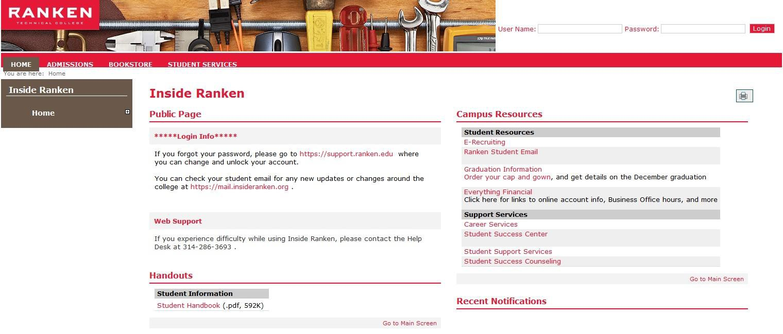
- Log in with your User Name and Password. For more info about your user name and password, see page 2.
- After you log in, you will see a red ribbon with several tabs across the top.
- Click on the “Academics” tab. Links to your courses will appear in red.
- Click on your online course. It will be the course with the letter “O” in the course number.

How to order the textbook for your online class

- First, decide how you will be paying: credit card, PayPal or by voucher through financial aid.
- If by credit card or PayPal, proceed to Step 4.
- If by voucher, go to your Ranken student email account to check for an email from MBS Direct that contains your student ID # and password. (These are not the same as your User name and password you use to go on Inside Ranken.)
- Go to the "Bookstore" tab on Inside Ranken.
“How to Navigate Your Online Courses.” Ranken Technical College, revised May, 2015. 3

- Scroll down and click on "Click Here to Order Your TextBooks" and then select your payment option.

- Select your textbook by check marking the correct Course ID and name. For example,

How to find the name of your instructor

Note: Knowing the name of your online instructor is important so you don’t email your questions to the wrong person. In addition to your actual online instructor, there may be several names listed as faculty on the course (found under the “Course Information” and “Collaboration” links) such as the VP for education, the dean of academic affairs, and the department chair.

There are two good locations to find the correct instructor for your course:

- Your instructor’s name, email address, and other contact information is located on the main page, center column, of the online course.
- Your instructor’s name, email address, and other contact information is included in the course syllabus.

How to email your instructor

Note: Only use your Ranken student email account. Also, it is important to send an email using the correct starting location such as the three easy options listed below. This will put your name (last name and first name) in the sender line. Otherwise, sent from the wrong location, your email may say “no_reply@ranken.edu,” which causes confusion to your instructor and may be deleted. Avoid sending emails from “Course Information” and “Collaboration” links on Inside Ranken.

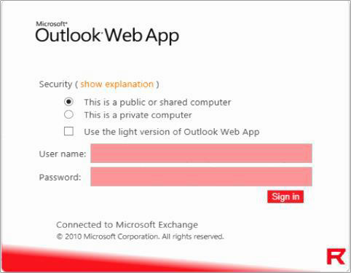
OPTION 1: FROM THE PUPLIC PAGE OF INSIDE RANKEN
  - Go to Inside Ranken (https://insideranken.org)
  - Without even logging in, the Public Page will open and in the right-hand column under Campus Resources you’ll see “Ranken Student Email.” Click to open.
  - Microsoft Outlook Web App should open.
  - Log in with your Ranken user name and password.

  - Click on “New” to open a blank email.

“How to Navigate Your Online Courses.” Ranken Technical College, revised May, 2015. 4

  - At the “To” line, type in your instructor’s email address.
  - If you don’t know your instructor’s email address, click on the “To” and type in your instructor’s last name and click on the search icon to find your instructor’s name from the list.
    - Find the correct name and click on it. That puts the name in the “To” line below.
    - When finished with names, click on “OK.”
  - In the “Subject” line, type in information to describe what the email is about.
  - In the text box, type in your question or comment.
  - Click on “Send” to submit.
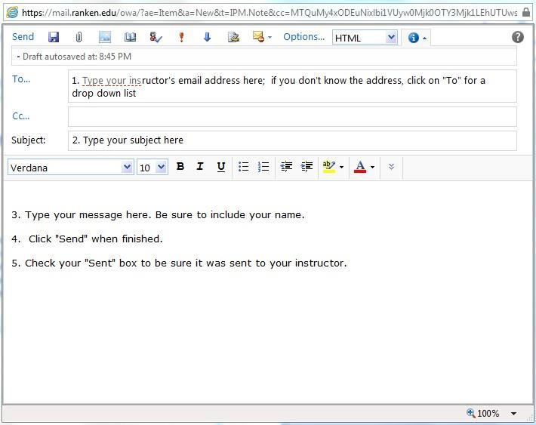

OPTION 2: FROM YOUR BROWSER
- Go to your browser and type https://mail.ranken.edu
- This will open Microsoft Outlook Web App.
- Login with your Ranken user name and password.
- Follow steps 5 – 10 above.

OPTION 3: FROM THE MAIN PAGE OF YOUR COURSE
  - Go to your course on Inside Ranken.
  - Look for your instructor’s email link on the main page, center column.
  - Click the link. An email should open with your instructor’s email in the “To” line.
  - In the “Subject” line, type in good information to describe what the email is about.
  - In the text box, type in your question or comment.
  - Click on “Send” to submit.

“How to Navigate Your Online Courses.” Ranken Technical College, revised May, 2015. 5

How to locate the syllabus and the “How to Get Started” document for each online course

- From the main page of your online course, find “Handouts” in the right-hand column.
- Under “Handouts,” there should be a syllabus and a “How to Get Started” document. Click on one of the documents to open it.
- Read each of these documents thoroughly to learn what is expected of you for this particular online course.
- Use these documents to answer the “About this Course” quiz.
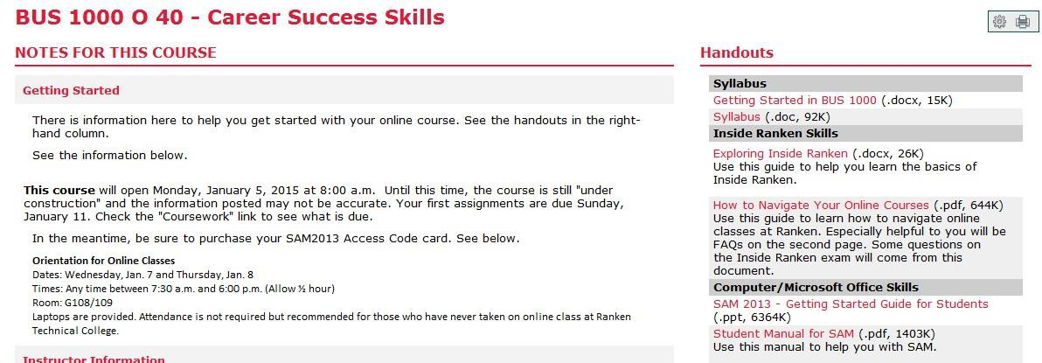

How to locate your assignments and their due dates

- From the main page of your online course, find “Coursework” in the left-hand column.
- Click to open.
- You should see your assignments in order of their due dates.
- At the top left is a blue box listing the next two assignments due. (Be careful. This is only for the next two, you may have 3, 4 or more assignments due.)
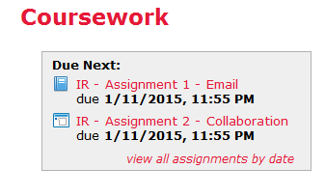
- There is also a link in that same box that says, “view all assignments by date.”
- If you can’t see your list of assignments or their due dates, contact your instructor.
- Generally, assignments are red and hyperlinked (underlined) when they are ready to be worked on. Assignments that are gray and not hyperlinked are either closed or have not yet been activated by your instructor.
- If the instructions and/or grading rubrics are not located under the assignments when you click on them, check to see if they are located under “Handouts” on the main page.
- If you have any questions about your assignments and due dates, contact your instructor.

“How to Navigate Your Online Courses.” Ranken Technical College, revised May, 2015. 6

How to submit assignments

Note: First, check your instructor’s instructions. Know what kind of document your instructor wants you to create—a reply to a post in Collaboration, or a Word document, PowerPoint, etc. to be uploaded to Coursework, Collaboration, or attached to an email. Secondly, create the document and save it to your computer or flash drive.

SUBMITTING ASSIGNMENTS IN COURSEWORK (Uploading an assignment)
  - From the main page of your online course, find “Coursework” in the left- hand column.
  - Click to open.
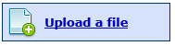
  - Click on the assignment to which you want to attach your document.
  - Click on the light blue box that says, “Upload a file.”
  - Follow the prompts to upload your saved document.
  - In this first step, the assignment waits in the file for you to revise and has not yet been sent to your instructor.
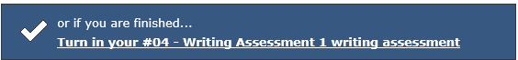
  - IMPORTANT: To submit your assignment to your instructor, you must click on the dark blue box that says, “Turn in your ….”

SUBMITTING ASSIGNMENTS IN COLLABORATION
Note: Follow your instructor’s instructions. Your instructor will either want you to simply reply to a post (or several posts), create your own post; or attach a document to a reply.
- From the main page of your online course, find “Collaboration” in the left- hand column.
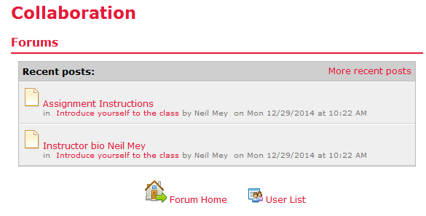
- Click to open.
- Click on “Forum” and then “Forum Home.”
- Be careful not to click on the recent posts but on “Forum Home” in order to find the topic folder you need.
- Click on the topic
folder in which your assignment is due.
- If your instructor wants you to add a post, look for a blue box along the left-side of the topic that says, “Add a Post” and click. Create the post and submit.
7. If your instructor wants you to reply to a post, click on the post that you are to reply to, look for a blue box along the right-side of the post that says, “Reply” and click. Create the reply and submit. Tip: Inside Ranken may time out while you are writing a long reply. You may want to write your reply in a Word document first; then copy and paste into the reply. When finished, click “Submit”.
8. If your instructor wants you to upload a document to a reply, open the reply and click on “Browse.” Select the saved document and click on “Open.” When finished, click “Submit.”

“How to Navigate Your Online Courses.” Ranken Technical College, revised May, 2015. 7

SUBMITTING ASSIGNMENTS AS ATTACHMENTS IN EMAIL
- Follow the instructions on page 4, “How to email your instructor.”
- To attach a file, click on the paperclip icon at the top.
- Select the saved document and click “Open.”
- This will attach your document and take you back to the email.
- When you are finished with your email, click “Send.”

How to take an online test or quiz

- From the main page of your online course, click “Coursework” in the left- hand column.
- Select the assignment (online quiz) and read the instructions. If there is a time limit posted, do NOT start until you are ready.
- Click to open the online test or quiz.
- Click on the light blue box that says, “When you are ready start the….”
- Read the questions carefully and select the best answers.
- When there is no time limit, you can save the progress of your test or quiz, and safely exit.
- To start again, click on the assignment link and the light blue box that now says, “Resume your….”
- When finished, click on the dark blue box that says, “Turn in your….”
- In many cases you will see your grade instantly. However, there are times when instructors have chosen to manually grade some questions. Your grade will appear when the instructor has finished.

Sending comments or questions to your instructor from within the course

Note: This is a better way to communicate with your instructor. Writing your comments in the text boxes provided is better than email because it stays on the course and doesn’t get lost. In addition to appearing on the course for your instructor to see, it is also sent to your instructor through email. Therefore, two messages are being sent.
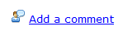
- Go to you course.
- If you have a question or comment about a particular assignment, you can go to Coursework and click on the assignment. Find the “Add a comment” link and open. When finished writing, click “Save”, or
- If you have a general question or comment about the course or your grade, you can go to Gradebook and add your comment or question there.
- Check back later to read your instructor’s response.

“How to Navigate Your Online Courses.” Ranken Technical College, revised May, 2015. 8

Confused about what to say in your first email assignment to your instructor? Here is an examle.

Dear Mr. Thompson,

This is to let you know that I have attended orientation for the online class. My name is John Smith and my cell phone number is 314-555-5555.

"How to Navigate Your Online Courses." Ranken Technical College, revised May, 2015. 9

Use this Self-Check Quiz to check your understanding of participating in online classes

- I fully understand the attendance policy for online classes at Ranken.
True False (See page 2)

- I know who to contact if I decide to withdraw from an online class. And, I also know that it is better to withdraw in person before I get dismissed for having more than the allowable number of unexcused absences.
True False (See page 2)

- I know how to order my textbook for the course.
True False (See page 3)

- I know my online instructor’s name and can email him/her using my Ranken student email account.
True False (See pages 4-5)

- I know where to find the syllabus and the “How to Get Started” document for my online class.
True False (See page 6)

- I know where to find all my upcoming assignments and their due dates.
True False (See page 6)

- I know how to upload a paper or PowerPoint to Coursework.
True False (See page 7)

- I know how to reply to a post in Collaboration.
True False (See page 7)

- I know how to take an online test or quiz.
True False (See page 8)

- I know how to submit a question or comment to my instructor for within the course in both coursework and in my gradebook.
True False (See page 8)

- I know what to say in my first email assignment to my instructor.
True False (See page 9)

If you have any questions about online classes, you may also contact Patsy Zettler, General Education Department Head at 314.286.3397 or pzettler@ranken.edu

“How to Navigate Your Online Courses.” Ranken Technical College, revised May, 2015. 10

25 COMMONLY ASKED INTERVIEW QUESTIONS

Early background
- What do you consider to be your most important accomplishments while growing up and why?
- What important values did you acquire during the early years?

Education
- How did your education prepare you for your current career?
- What kind of student were you?
- What were your favorite courses? Why?
- How did you make use of your spare time?

Work Experience
- How did you select your career? Who influenced you most in your decision?
- Of past positions you have held, which did you like most (or least)? Why?
- What were the events that led to your departure from your last position?
- If we were to contact your most recent boss as a reference, what would he/she say about you?
- Do you work well under pressure?
- How did you get along with your co-workers?

Personal Effectiveness
- How would you describe yourself?
- What adjectives would others use to describe you?
- What are your three greatest strengths?
- What is your greatest weakness?
- In your career to date, what would you consider to be your one greatest achievement?
- Have you ever been fired or asked to resign?
- Can I see examples of your work?

General Questions
- Why are you interested in working for this company?
- Why are you looking to change careers?
- How do you account for the gaps in your employment history?
- What do you think about traveling?
- What salary/benefits are you looking for?
- Where do you see yourself in five years? Ten years?

Source: LaGuardia Community College. “25 Commonly Asked Interview Questions.” http://www.lagcc.cuny.edu/careerinfo/pdf/25_Commonly_Asked_Interview_Questions.pdf

Points Possible
Job Posting Rubric
Submission | Score
5 | 5
Print out or copy of job posting
0 | 0

Points Earned
Cover Letter Rubric
Formatting | Student’s Contact Info | Letter Content | Punctuation, Spelling,  Grammar | Score
6 | 4 | 6 | 9 | 25
New Times Roman or Arial font, 12 point, block style (3) Employer's address was placed after student's (1) Appropriate greeting (1)  Appropriate salutation  (1) | All important contact info was included: name, address, phone number, email address (4) | Par 1 – referred to job ad – used  keys words from the ad (2)  Par 2 – highlighted skills, work experience, and education (2)  Par 3 –requested action (2) | All words spelled  correctly (3)  All punctuation correct (3)  Grammar is correct (3)
0 | 0 | 0 | 0 | 0

Points Possible

Points Earned
Resume Rubric
Formatting | Student’s Contact Info | Resume Content | Punctuation, Spelling, Grammar | Score
8 | 4 | 8 | 12 | 32
New Times Roman or  Arial font, 11 or 12  point (2)  Margins were 1" all  around (2)  Layout was clean  looking (2)  All on one page (2) | All important contact info was included at top of page : name, address, phone number, email address (4) | Skills – listed all appropriate skill  sets related to job description (3)  Work History or Experience – listed in reverse chronological order; included military if applicable (2)  Education – listed college and/or certificates in reverse chronological order (1)  References - included line that references were available upon request (2) | Used action verbs to start phrases; no complete sentences(3)
All words spelled
correctly (3)

All punctuation correct
(3)

Grammar was correct (3)
0 | 0 | 0 | 0 | 0

Points Possible

Points Earned

Points Possible
Reference List Rubric
Formatting | Student’s Contact Info | List Content | Spelling | Score
9 | 4 | 9 | 3 | 25
New Times Roman or Arial font, 12 point, and 1 " margins all around (3)  Centered title "Reference List" (3)  List on left margin and appropriate spacing between references (3) | All important contact info was included: name, address, phone number, email address (4) | Listed a minimum of 4 professional references (4)  Gave each reference's name, company, address, phone number and email address (5) | All words spelled correctly (3)
0 | 0 | 0 | 0 | 0

Points Earned
Thank You Letter Rubric
Formatting | Student’s Contact Info | Letter Content | Punctuation, Spelling, Grammar | Score
6 | 4 | 6 | 9 | 25
New Times Roman or Arial font, 12 point, block style (3)  Employer's address was used (1)  Appropriate greeting (1)  Appropriate salutation  (1) | All important contact info was included: name, address, phone number, email address (4) | Par 1 – thanked interviewer for his/her time, stated date interview took place, and for which job applicant was interviewing (2)  Par 2 – reiterated skills, work experience, and education that related to job; stated why applicant is best candidate for the job (2)  Par 3 – concluded with looking  forward to hearing from them soon (2) | All words spelled correctly (3)  All punctuation correct (3)  Grammar is correct (3)
0 | 0 | 0 | 0 | 0

Points Possible

Points Earned

Points Possible
Mock Interview Rubric
Appearance | Portfolio | Responses to Questions | Nonverbals | Score
5 | 3 | 16 | 11 | 35
Wore appropriate interview clothing or could explain what would be worn (3) Hair groomed, face clean shaven or beard groomed (2) | Brought extra copies of resume and reference list in clean folder (3) | Responded appropriately to all questions (4)  Expanded on answers and gave  examples (4)  Demonstrated he/she was prepared for questions with well- thought-out answers (4)  Was prepared to ask questions of the interviewer and had researched the company (4) | Good eye contact throughout (2)  Good handshake before  and after (4)  Acted in a confident manner (3)  Used respectful tone and was courteous (2)
0 | 0 | 0 | 0 | 0
Total Points Possible  Total points earned |  |  |  | 147  0

Points Earned

Points Possible
Assignment 1 - Email Rubric
Receiver | Sender | Email Content | Punctuation, Spelling, Grammar | Score
3 | 3 | 3 | 3 | 12
Email was sent to correct receiver as requested | Email came from student's Inside Ranken email account | Student included info in email as requested | All words spelled correctly (1)  All punctuation correct (1)  Grammar is correct (1)
0 | 0 | 0 | 0 | 0

Points Earned
Assignment 2 - Collaboration Rubric
Formatting | Procedure | Punctuation,  Spelling, Grammar | Score
6 | 3 | 3 | 12
Word count was met (2)  All questions in original post were answered in reply (4) | Student submitted reply to original post (3) | All words spelled correctly (1)  All punctuation correct (1) Grammar is correct (1)
0 | 0 | 0 | 0

Points Possible

Points Earned

Points Possible
Assignment 3 - Upload Document to Coursework Rubric
Formatting | Procedure | Score
6 | 4 | 10
Word document was used (2)  Content was copied from Collaboration reply and pasted as requested (2)  Document was saved and titled as requested (2) | Document was uploaded to correct assignment link (2)  Student clicked on the "Submit" link to send it to the instructor (2)
0 | 0 | 0
Total Points Possible Total points earned |  | 34  0

Points Earned

Career Success Skills Rubric by Sections
Total Points Possible
Total Points Earned

1. Computer/Microsoft Skills (Completed on SAM CHALLENGE)
Computer Concepts (5 questions)
Excel 2013 (34 questions)
Internet Explorer 10 (8 questions)

Outlook 2013 (18 questions)
PowerPoint 2013 (23 questions)
Word 2013 (29 questions)
Job Posting 5
100

Assignment 1: Email 12
Total Possible |  | 100
2. Job Readiness Skills (Portfolio)
 | Cover Letter | 25
 | Resume | 32
 | Reference List | 25
 | Thank You Letter | 25
 | Mock Interview | 35

Total Possible | 147
3. Inside Ranken Skills (Completed on Inside Ranken)

Assignment 2: Collaboration | 12
Assignment 3: Coursework | 10
Online Exam | 35

Total Possible | 69
Total Possible for all 3 sections | 316 | 0

